**FIS**

**NAME: ANKITA VISHNU DAHIPHALE**

**EMPLOYEE ID: E5685578**

TABLE LIST:

**TABLE DATA**

AIR_CREDIT_CARD_DETAILS

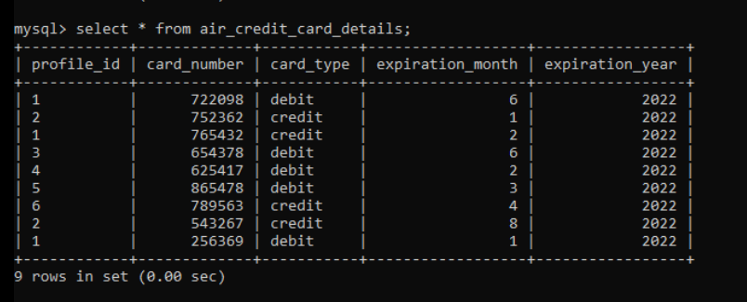

AIR_FLIGHT

AIR_FLIGHT_DETAILS

AIR_PASSENGER_PROFILE

AIR_TICKET_INFO

|  |  |
| --- | --- |
|  | **AIRLINE QUERIES SOLUTIONS:**  **1**. Write a query to display the average monthly ticket cost for each flight in ABC Airlines. The query |
|  | should display the Flight_Id,From_location,To_Location,Month Name as “Month_Name” and average |
|  | price as “Average_Price”. Display the records sorted in ascending order based on flight id and then by |
|  | Month Name.  **Solution :**  **select a.flight_id,a.from_location,a.to_location, monthname(b.flight_departure_date) as month_name, avg(price) as average from air_flight a join air_flight_details b on a.flight_id=b.flight_id where a.airline_name='air01' group by a.flight_id,month_name order by a.flight_id,month_name;** |
|  |  |
|  |  |
|  | **2.** Write a query to display the number of flight services between locations in a month. The Query |
|  | should display From_Location, To_Location, Month as “Month_Name” and number of flight services |
|  | as “No_of_Services”. Hint: The Number of Services can be calculated from the number of scheduled |
|  | departure dates of a flight. The records should be displayed in ascending order based on |
|  | From_Location and then by To_Location and then by month name. |
|  | **Solution:**  **select a.from_location,a.to_location,monthname(b.flight_departure_date) as month_name, count(b.flight_departure_date) as no_of_services from air_flight a join air_flight_details b on a.flight_id=b.flight_id group by month_name order by a.from_location, a.to_location,month_name;** |
|  | **3.** Write a query to display the customer(s) who has/have booked least number of tickets in ABC |
|  | Airlines. The Query should display profile_id, customer’s first_name, Address and Number of tickets |
|  | booked as “No_of_Tickets”Display the records sorted in ascending order based on customer's first |
|  | name. |
|  | **Solution:**  **select a.profile_id,a.first_name,a.address,count(b.ticket_id) as no_of_tickets from air_passenger_profile a join air_ticket_info b on a.profile_id=b.profile_id join air_flight d on b.flight_id=d.flight_id where d.airline_name='air01' group by a.profile_id having count(b.ticket_id)<=all (select count(ticket_id) from air_ticket_info where flight_id in (select flight_id from air_flight where airline_name='air01') group by profile_id) order by a.first_name;** |
|  | **4**. Write a query to display flight id,from location, to location and ticket price of flights whose |
|  | departure is in the month of april.Display the records sorted in ascending order based on flight id and |
|  | then by from location.  **Solution:**  **select a.flight_id,a.from_location,a.to_location,b.price from air_flight a join air_flight_details b on a.flight_id=b.flight_id where monthname(b.flight_departure_date)='april' order by a.flight_id,a.from_location;** |
|  |  |
|  | **5.** Write a query to display the no of services offered by each flight and the total price of the services. |
|  | The Query should display flight_id, number of services as “No_of_Services” and the cost as |
|  | “Total_Price” in the same order. Order the result by Total Price in descending order and then by |
|  | flight_id in descending order.Hint:The number of services can be calculated from the number of |
|  | scheduled departure dates of the flight  **Solution:**  **select a.flight_id,sum(b.price) as total_price, count(a.flight_departure_date) as no_of_services from air_ticket_info a join air_flight_details b on a.flight_id=b.flight_id group by flight_id order by total_price desc,flight_id desc**; |
|  |  |
|  | **6.** Write a query to display profile id of passenger(s) who booked minimum number of tickets. In case |
|  | of multiple records, display the records sorted in ascending order based on profile id.  **Solution:**  **select a.profile_id from air_passenger_profile as a join air_ticket_info b on a.profile_id=b.profile_id group by a.profile_id having count(ticket_id)=(select max(c) from (select count(ticket_id) as c from air_ticket_info group by profile_id)t) order by a.profile_id;** |
|  |  |
|  | **7.** Write a query to display unique profile id,first name , email id and contact number of passenger(s) |
|  | who travelled on flight with id 3178. Display the records sorted in ascending order based on first |
|  | name.  **Solution:**  **select a.profile_id,a.first_name,a.mobile_number,a.email_id from air_passenger_profile a join air_ticket_info b on a.profile_id=b.profile_id where b.flight_id='7771' order by a.first_name;** |
|  |  |
|  | **8.** Write a query to display the credit card type and no of credit cards used on the same type. Display |
|  | The records sorted in ascending order based on credit card type Hint: Use CARD_COUNT as alias name for no of cards.  **Solution:**  **Select card_type, count(card_type) card_count from air_credit_card_details group by card_type order by card_type;**   |  |  | | --- | --- | |  |  | |
|  |  |
|  | **9**. Write a query to display the flights available in Morning, AfterNoon, Evening& Night. The Query |
|  | should display the Flight_Id, From_Location, To_Location , Departure_Time, time of service as |
|  | "Time_of_Service". Time of Service should be calculated as: From 05:00:01 Hrs to 12:00:00 Hrs - |
|  | Morning, 12:00:01 to 18:00:00 Hrs -AfterNoon, 18:00:01 to 24:00:00 - Evening and 00:00:01 to |
|  | 05:00:00 - NightDisplay the records sorted in ascending order based on flight id  **Note : Couldn’t Solve it**  Solution:  Select flight_id, from_location, to_location, departure_time, (SELECT DATE(D.datumTijd),  CASE WHEN TIME(D.datumTijd) BETWEEN '05:00:01' AND '12:00:00' THEN Morning  WHEN TIME(D.datumTijd) BETWEEN '12:00:01' AND '18:00:00' THEN Afternoon  WHEN TIME(D.datumTijd) BETWEEN '18:00:01' AND '24:00:00' THEN Evening  WHEN TIME(D.datumTijd) BETWEEN '00:00:01' AND '05:00:00' THEN Night  END  as time_of_service from air_flight) |
|  |  |
|  | **10.** Write a query to display the number of flights flying from each location. The Query should display |
|  | the from location and the number of flights to other locations as “No_of_Flights”. Hint: Get the |
|  | distinct from location and to location.Display the records sorted in ascending order based on from |
|  | location.  **Solution:**  **Select from_location, count(flight_id) no_of_flights from air_flight group by from_location order by from_location;** |